**SPOTIFY PROJECT**

**BRIEF**

The mission was to improve one of Spotify features. Spotify team did a recently app research to find out that people are happy with what Spotify is offering but the main issue is they find very difficult to find what they are looking for as for them everything is “all over the place”.

The specific challenge is to improve Information Arquitecture in Spotify.

The sprint took xxx weeks

BUSINESS GOALS

-Where do you see Spotify in 5 years time? Going above Youtube and being the worldwide platform in streaming music.

Business Goals

Spotify is a music, podcast, and radio streaming service, officially launched on 7 October 2008. Spotify is a freemium service, meaning that basic features are free with advertisements, while additional features, including improved streaming quality and offline music downloads, are offered via paid subscriptions.

1.Free

Develop a wide range of innovative advertising formats — Audio Ad, Homepage Takeover, Video Takeover, Branded Playlist etc.

2. Premium

Have users invest their time to build up a library and explore functions. Offer key features in premium version.

Stream content — buying and curating more and more content. Spotify provides access to over 60 million songs in 2020. Every time that a user streams a song, Spotify gets paid.

3. More users

Retain existing users

Build a social community within the app

Encourage sharing across other social media platforms

Conduct marketing campaigns

Build partnership with third-party platforms

**RESEARCH GOALS**

1. Define people's common behaviours when streaming music.
2. Determine what makes a streaming music experience satisfying.
3. Determine users’ biggest frustrations when streaming music
4. Understand how users interact with each other on the music streaming services.
5. Define the standard for streaming music services.
6. Understand user needs when streaming music and identify areas for improvement

**SECONDARY RESEARCH: MARKET RESEARCH**

As a premium user of Spotify services I did a thorough analysis of the app on my phone and also the website. I also conducted a research on Tidal, Youtube and iTunes.

**SECONDARY RESEARCH: COMPETITIVE RESEARCH**

A competitive analysis was performed to understand the strengths, weaknesses, similarities, and differences between competitor music streaming services in the industry.

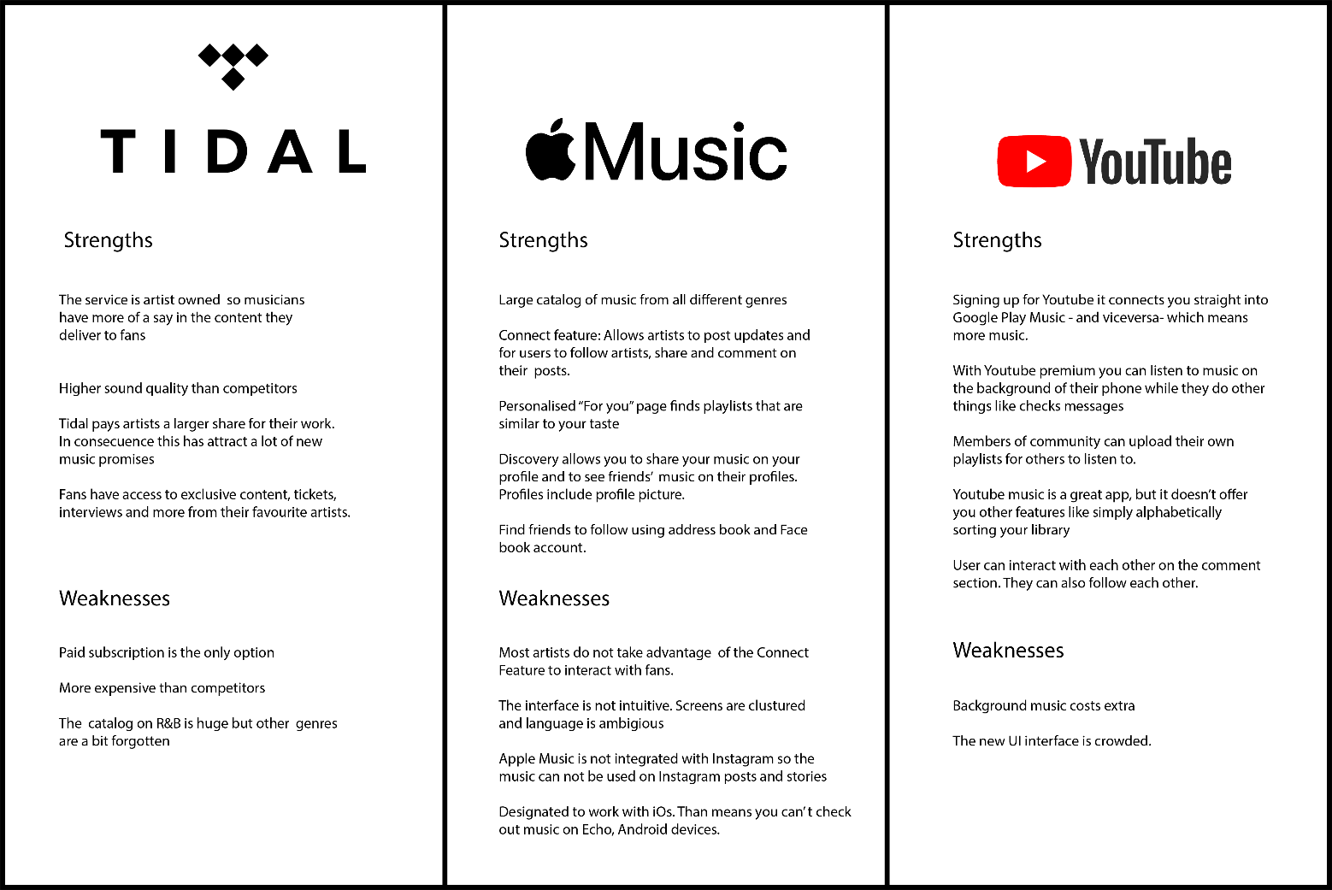

**Findings**

Social Features: None of the leading streaming services have a fully fleshed out social feature. It appears to be a function that is not expected by users but is appreciated when it is available.

Exclusive Content: This seems to be a major key to attracting users. Platforms aim to show that they can deliver the newest, most unique content before competitors. exclusive access is used in place of social communication to make users feel a sense of community and “in the know.”

Personalization: Most personalization on these apps takes form as curated playlists. While some apps give the user a profile page, there is limited functionality or options for it.

**USER GOALS**

PERSONA

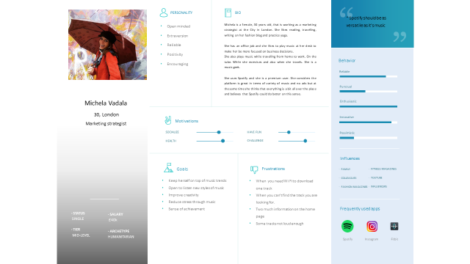

-Age: 25-35

-Device: 50% Android 50% IOS

-Songs of collection: >1,000 songs

-Frequency of use: >2 hours everyday (premium user)

-Needs: Access to all the music I like, discover new music and create great playlists

-Michela has used Youtube app before and she thinks is a very reliable source to find loads of music and videos that are relevant to her and also to discover something relevant to her.

-She decided to use Spotify because the quality of music was better. And also she didn’t have to deal with many ads like Youtube.

-Another great advantage is that she could use another apps while listening to Spotify.

-She likes pop and classic music and she tries to find playlists that are close to this style but at the same time she is happy to try new styles and suggestions from other users.

-She listens to music few times everyday. In the morning on her way to work she uses Spotify for half and hour. On her way back home another half and hour. If she is practising yoga then she uses another playlist from Spotify.

-She is using the Premium version because she thinks is good value for money and then you are free of ads and you can download music and play it when you don’t have internet like on the tube or a plane.

-She also thinks that Spotify is a bit disorganised and is hard to find your way around it.

USER GOALS

User Goals

1.Listen to and save music

-Quick and easy way to search a song

-Build a personal music library and listen repeatedly

2. Discover new music

-Discover Weekly/Daily Mix — listen to recommended songs

3. Get information about preferred artists/ genres at first hand

- Newsletter

- Predetermined settings

SURVEY/ INTERVIEW

We interviewed 10 people that were Spotify users and we asked these questions

**Music questions**

* What are the main streaming music apps you use?
* How often do you listen to music?
* What times of the day you listen to music?
* Do you pay premium service for the music apps you use?
* If the answer is yes, why?
* If the answer is no, why?
* Are you doing any other activity at the same time you play music?

**App questions**

Please open Spotify either on your phone or your computer.

1. When you open Spotify what is the first thing that you look for?
2. I would like you to tell me how do you find the home page. If you scroll down you will have find music options. What is your opinion about these options? How do you feel about it?
3. Some of the music labels are “Your heavy rotation”, “Jump back in” or “Guilty pleasures”. Do you identify yourself with these names? Do you know the meaning? Would you consider clicking on these labels?
4. What is the most and the least relevant information for you on the homepage? Please write the 3 most important and 3 less important.
5. Which ones would be the 3 most important features on a music streaming service?
6. How would you feel if the app you are using is suggesting new music to you?
7. Which ones would be the weakest and strongest points of Spotify when it comes to compare it with Youtube
8. How do you feel about sharing some of the music you listen to with your friends and family?
9. Which is your preferred source to get information regarding latest updates from your favourite artists?
10. How do you feel about having a personalised playlist created by the app you are using?
11. Is there a feature that you would like to see included on this app.
12. Anything that would like to add?

CONCLUSIONS FROM SURVEY

* All of the participants use Spotify as a main source to listen to music. Some of them use iTunes and Youtube as a secondary source to stream music.
* All of them listen to music on a daily basis and 85% of them is paying for a premium service so they can skip ads.
* When they open Spotify the first they look for is “my recent playlist”. If the scroll down and they see all the music options they think is a great idea but also agree that is too much crowded information.
* The listen on a common basis to almost all the music labels as they find it useful.
* Most important buttons: My library, recently played and my favourite artists.
* Less important buttons: podcast, editor’s pick and recommended stations.
* The 3 most relevant features for them on an app are:

1. No adds
2. Play when offline

3. Music suggestions

* They are all happy to listen to new music as long as the app knows their preference in genre and artists.
* Compared to other streaming services the weakest point of Spotify is that there is no video, although participants don’t feel upset about it. The strongest would be that you don’t need to be online to listen to music.
* They have 50% 50% mixed opinion about sharing music friends and family. Half of them think is a great idea to express and share their songs with closed ones. Others find it pointless and they turned off the option.
* Regarding latest updates from artists, they usually find it on social media or just browsing the internet
* Almost all them like the idea of having a personalised playlist created by the app but always taking into account their own preferences in terms of genre and artists.

EMPATHY MAP

We created an empathy based on 4 participants comments and nonverbal expressions

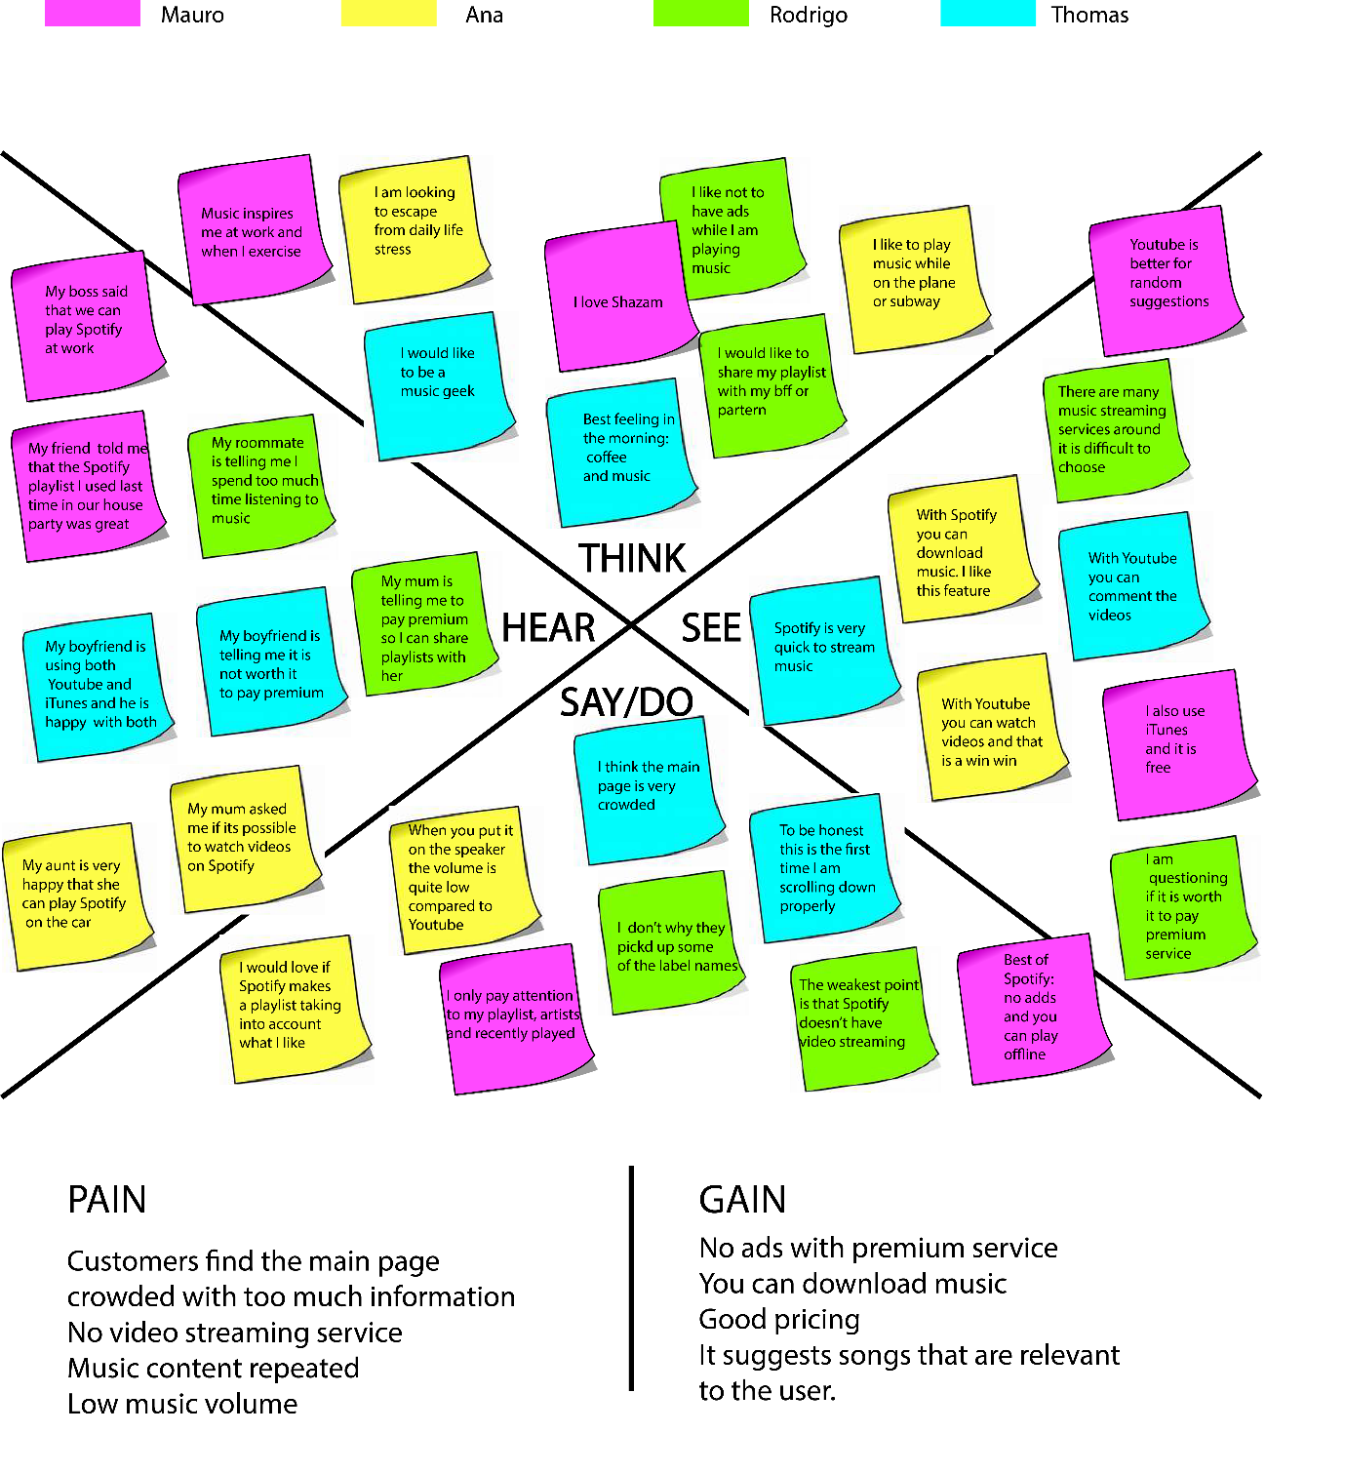

**DEFINE AND IDEATE**

After wrapping up primary research, I dug deeper into the insights and needs I had generated. First, I restructured insights into POV statements, an actionable problem statement that defines the design challenge. Next, I restructured those POV statements into How Might We questions that would generate solution-oriented brainstorming.

|  |  |  |  |
| --- | --- | --- | --- |
| Users | Need | Insight | HMW |
| Spotify users | need to find an easy journey to get their favourite music | because when they enter the main Spotify page they think is a very crowded | How can we help them to create an easy journey on the main page? |
| Spotify users | rely on personalised playlists to have music they like | because it is a straight forward process to them and they don’t need to start searching. | How can we help Thomas to create a curated playlist with his fav artists and songs? |
| Spotify users | use social media to get the latest updates on their favourite artists | because they like to keep on top of music that interests them | How can we help Thomas to have the latest information about artists and genres? |

**Business and User Goals**

I reflected on the business goals, user goals, and technical considerations to find a happy medium for all stakeholders. Once I had identified common areas, I could decide what product features were necessary for the prototype.

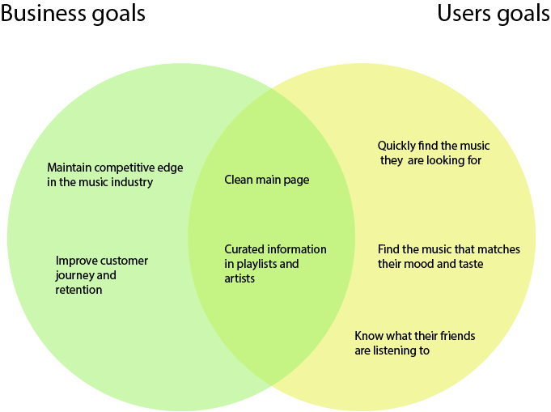

INFORMATION ARQUITECTURE

|  |  |  |  |
| --- | --- | --- | --- |
|  | Priority 1 | Priority 2 | Priority 3 |
| Goal | **Help customers redesigning the main home page making it**  **Very clean** | **Give customers a curated music experience tailored to their personal preferences** | **Help customers find the most current, up to date information about their favourite artists and genres** |
| Features | Redesign:  Delete all labels that participants declared were irrelevant to them  Focus on the 3 most important labels for participants  Change the position of elements on the page to create an easy user  journey | Updated playlist pages:  Settings: you can select your favourite artists and genres.  Spotify playlist: Based on your settings and your recent playlist, Spotify will create a weekly playlist just for you. | Updated artist pages:  Notifications: sign up to have the newsletter with the latest information about your artists  Settings: you can select your favourite artists and that it is saved onto the system  Clickable button on the main page with curated information regarding your favourite artists  Spotify live video for artists |
| Metrics | Track:  User testing with participants regarding new interface  Time participants spend on the main page  Number of clicks on each button on the main page  Users review through  Survey | Track:  Number of users changing their settings  Number of users clicking on that playlist  Client satisfaction survey | Track:  Percentage of users that change their settings  Percentage of users that sign up for alerts  Percentage of users  That click on artists updates button  Percentage of users that stream Spotify lives |

**INFORMATION ARQUITECTURE**

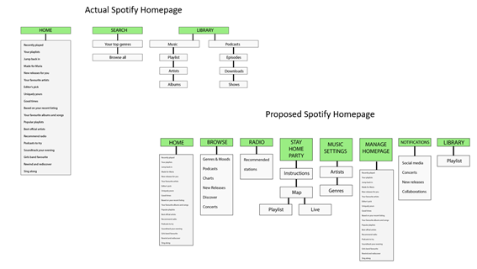

TRANSLATING INTO DESIGN

* We decided to create four new options on the main menu that we considered were relevant to the project: Stay Home Party, Music Settings, Manage Homepage and Notifications.
* We developed three of them: Manage Homepage, Notifications and Music Settings. Stay Home Party was developed in another stage.

Manage Homepage

This menu option was created because some users stated that their homepage was messy and they would like to have music that is relevant for them. That is why we will let them add and remove all the music modules they would like to have on their main homepage.

Music settings

In music settings they will have the option to choose their preference with artists and genres and have curated lists on their main homepage.

Notifications

Some users claimed that they would like to have notifications from their favourite artists and genres and that is why we created another button on the main bar to have them informed of any concert, collaboration, releases that are relevant to them.

**USER TESTING CREATING WIREFRAME**

Now that all the design and planning have been laid out it was time to create a wireframe to test with people. The same interviewees for the competitive research helped us analysing this wireframe

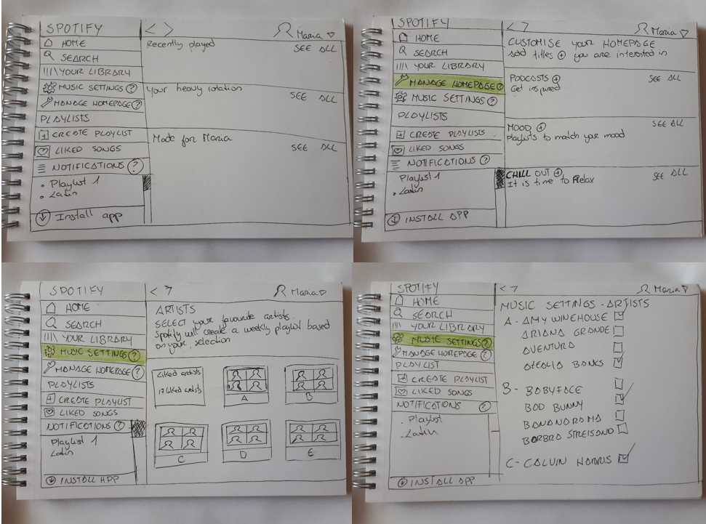

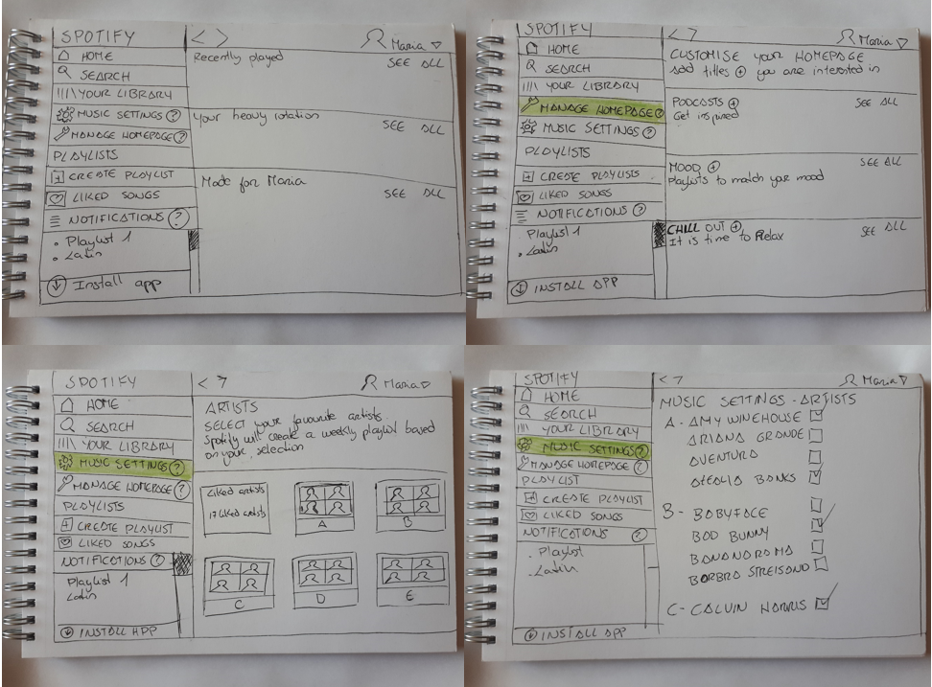

**Validation research**

After designing the wireframes we did a second round of interviews with the same participants that took the user testing with our competitors and these were the results:

The main findings from the early validation research with paper prototypes were:

* Participants found it really interesting that **Music Settings** had been added to the main menu
* **Manage Homepage** was also very welcomed
* Participants were happy that the main homepage wasn’t cluttered with so many music options
* They gave a thumbs up to the concept of moving the music modules up and down on the page, depending on importance
* Because this case study was made during the Covid-19 lockdown, there were suggestions to create a **Stay Home Party,** with artists live streaming songs and content.

**Final (high fidelity) prototype**

Building on the existing Spotify main design, I added **Music Settings**, **Manage Homepage Notifications** and **Stay Home Party** to the main menu. The first two were developed using the existing Spotify design guidelines and Stay Home Party was created from scratch.

For Stay Home Party, we created a little festival map. Every house on the map has a host and guests (all of them famous artists). There are two possible options when you are at the party:

* You can access one of the houses as a guest and hit play to start the playlist. With this option you can invite other Spotify friends and have a video call while you listen to the playlist on the background.
* Alternatively, you can also join a **live streaming** Home Party with the host of each party and enjoy the virtual performance.

Here are some screen grabs of the final project

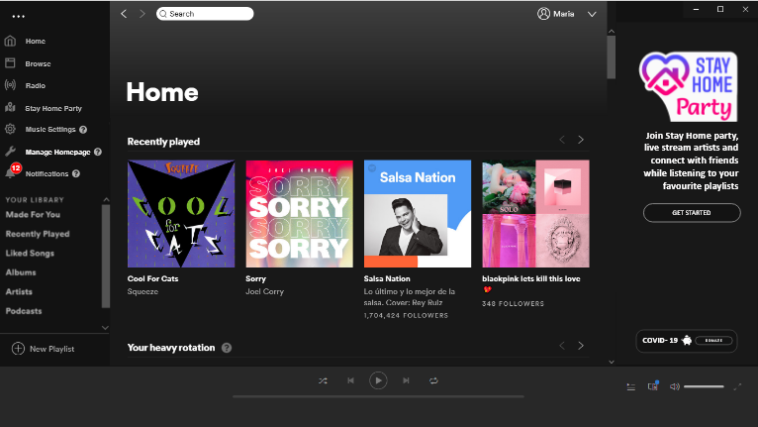

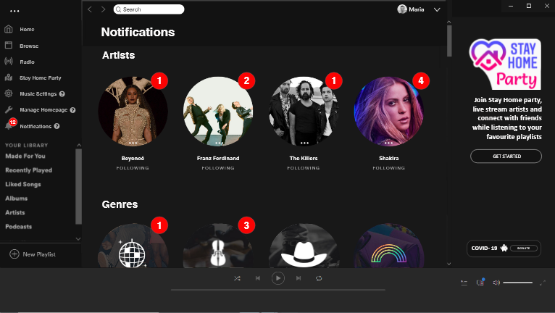

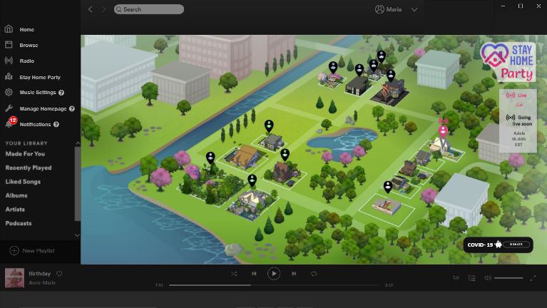

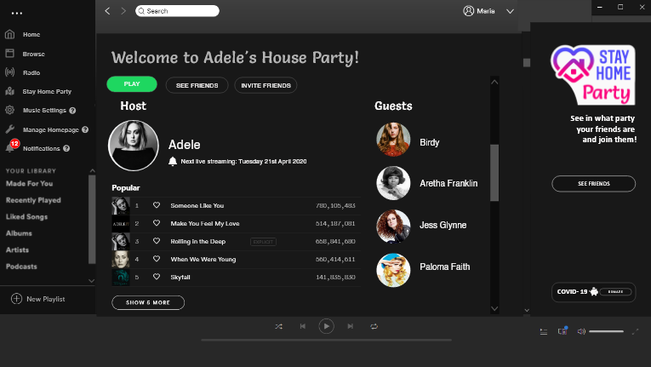

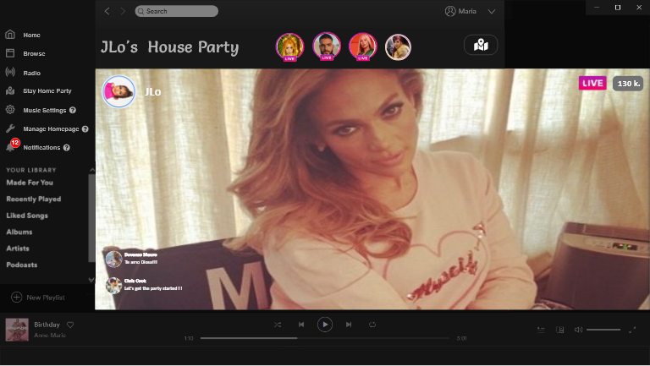

**[Spotify video]**

**The result**

Working on this project, I learned that designing a desktop app presents very different challenges to mobile apps. The existing Spotify desktop app had features that weren’t in the Android app for my smartphone.

I was very encouraged by the feedback I received in early research to my sketches for some “see what your friends are playing” functionality, and this developed into the Stay Home Party. Originally a response to the Covid-19 lockdown, this feature has taken on a life of its own.

I am currently contacting Spotify team to pitch my ideas for the updated Spotify app.